Context Coordination Initial Experiment with 540 participants.

All conditions have the order of the features on the base and the order of the stimuli randomly assigned.

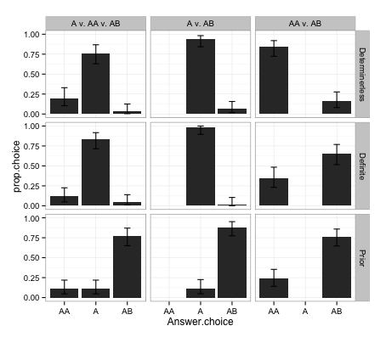

All Stimuli: Houses, Lunchboxes, and Plates

Example Prompts:

Determinerless: Bob can only say one word to communicate which lunchbox he is looking at and he says:

**Cookie**

Definite Determiner: "I am looking at the plate with **the spoon."**

Prior: Which lunchbox do you think Bob is looking at?

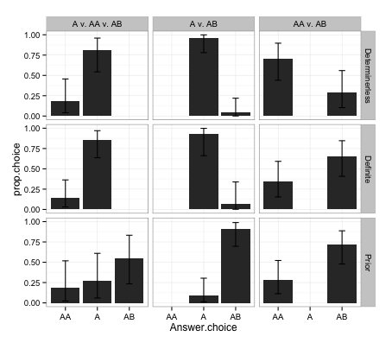

House Stimuli (Houses, bicycles, and cars)

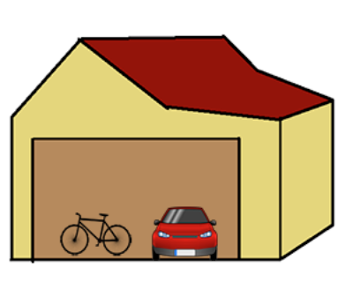

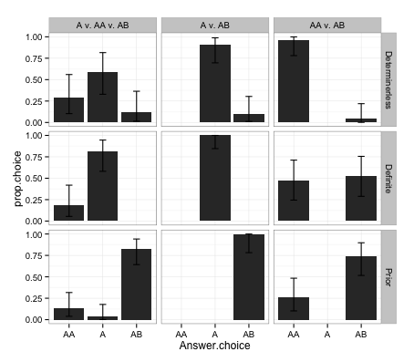

Lunchbox Stimuli (Lunchboxes, Apples, and Cookies)



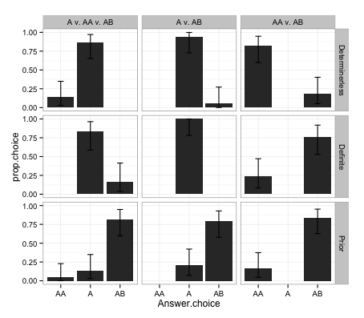

Plate Stimuli (Plates, forks, and spoons)

